Two questions to be answered:

* Differentially expressed genes?
* Involved pathways?

1. QC check against the FASTQ files with FastQC

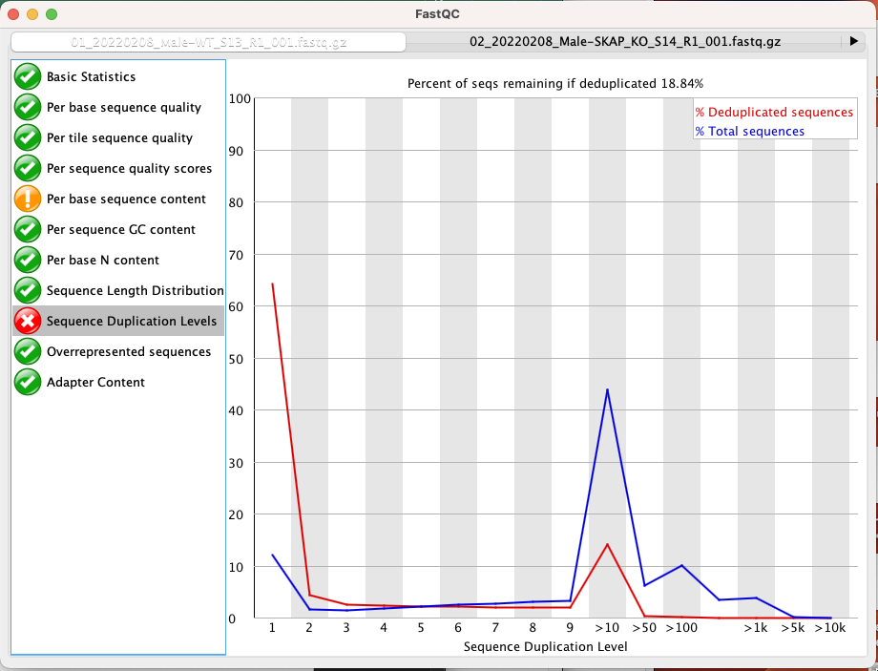

*“This is a good RNA-Seq library, but actually represents the kind of profile you might see in any enriched experiment.  In general FastQC makes the assumption that you expect to be looking at a diverse library with a roughly even representation of all sequences.  In enriched libraries this isn’t going to be true and there are certain sequences (highly expressed genes or enriched peaks in a ChIP) where you want the sequence to occur more frequently.  Above a certain read density the only way to place more reads into a region is via duplication so we might not expect to have a properly diverse library.”* –Simon Andrews

1. Prepare mac:

Install samtools